Objective

For my study of the ‘Wine Reviews’ data downloaded from Kaggle.com, I will be utilising the Python 2.7 programming language to conduct the analysis. I aim to investigate the following questions:
- Are there differences in the mean number of rating points awarded for the same varieties of wine produced in different countries?
- Does a higher price correlate with a higher points rating? Are wines produced in certain countries ‘better value’, e.g. do they have a better review score to price ratio?
- Areni, CS et al. state that ‘French wines enjoy a prestige that is unmatched by any other wine producing country, and there is little doubt that the "region equity" of France is central to the success of French wineries around the world.’ Is there a bias toward French wines because of their established reputation? Are they disproportionately expensive for their rating points in this dataset?
I have chosen the Chardonnay the variety of wine to analyse. My reasoning for this was that when counted, the dataset has more reviews on this variety than any other (13775) and the reviews have a good geographical spread across four continents.

Description of Dataset – Dataset one

I downloaded my Wine review dataset from Kaggle.com. The data has been scraped and collated from Wine Enthusiast magazine and the set contains their top-rated 150,000 reviews. The dataset was downloaded as a CSV file.
The data is split into ten columns:
Country – The country of origin of the wine (string data type)
Description – a detailed review of the wine completed by the wine reviewer
Designation – where most of the grapes (95% minimum) have come from
Points – the score awarded to the wine by Wine Enthusiast Magazine (numeric integer, marked between 80 and 100)
Price - The price of the wine in US dollars (numeric integer)
Province – The established wine producing area that the wine comes from (string)
Region 1 – The greater region where the wine is produced (string)
Region 2 – Further information on the wider region (string)
Variety – The type of grape(s) that the wine is made from (string)
Winery – The name of the winery that the wine came from (string)

The main columns that I will focus on are ‘country’, ‘variety’, ‘price’, and ‘points’. I have chosen these columns because I want to focus on mean review scores and treat these as a rating of the quality of the wines. I wish to also do a comparison between these mean points ratings and the with mean prices.
For the analysis I have excluded blends (wines that use a combination of different grape varieties) and included only wines that are labelled solely as the Chardonnay variety.
I used the Spyder Notebook from the Anaconda package to write the code and create the visualisations for this analysis. Spyder is helpful because in a single interface you can run code and see charts and graphs simultaneously. If there is an error in the code (spelling errors etc.) it points out where the issue is immediately so that you waste less time de-bugging.
Spyder already has several libraries built in so it was easy and convenient to access them. I used Pandas extensively to manage data frames and subsets and used Matplotlib for most of the charts and graphs. I also utilized the ‘math’ library for some help with setting limits in bar charts and the ‘statsmodels.stats.multicomp’ library for a convenient way to run statistical Anova and Tukey tests in Spyder (see appendix 1).

Design Documents – Dataset one

The first task in this analysis was to open the dataset in Python and clean the data to remove any missing values. Once I was satisfied with the integrity of the dataset the next objective was to get a high-level overview of the data, starting with discovering the countries of origin that this variety of wine had been reviewed most.
This analysis revealed that wines from the US had been reviewed significantly more times than any other country (62,139 reviews). Fig 1. Illustrates the top ten countries in terms of numbers of reviews completed for all wine varieties and demonstrates this difference.
Next, I created a subset of this data to see who the biggest producers of Chardonnay wine were according to the numbers of reviews in my dataset (Fig.2), as expected the US still had the most reviews (8127). France however moved into second place and Italy fell back to fifth, suggesting that Italy does not produce a high output of Chardonnay proportionate to their production of other varieties:

Fig.1 Total numbers of reviews Fig.2 Total numbers of Chardonnay reviews
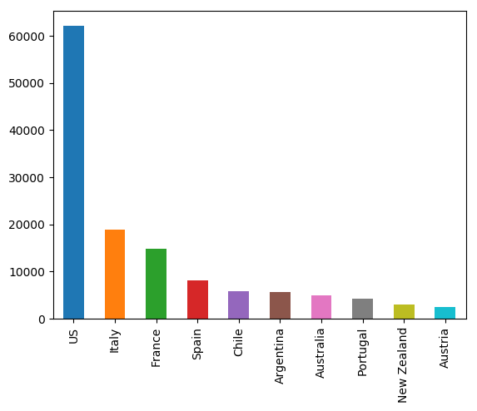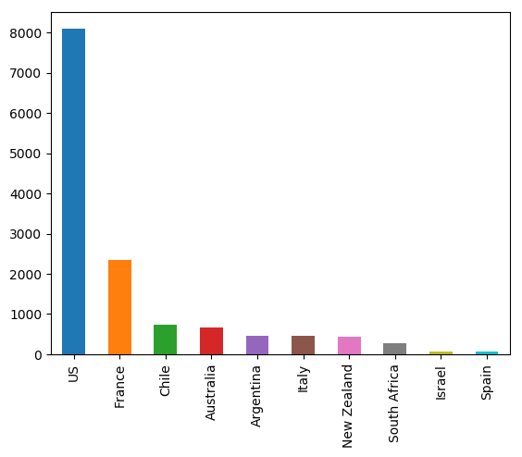

As we can see from Fig.2, the top seven most reviewed countries for Chardonnay are (in order) the US, France, Chile, Australia, Argentina, Italy and New Zealand. Since the numbers of reviews become relatively small after this, I chose to focus on these seven countries for my analysis.
I needed to calculate a mean rating points score that each country received for their Chardonnays to facilitate comparison. I firstly found the mean score for all 14482 Chardonnay variety wines in the dataset to have a global benchmark for comparison.
The result of this (rounded to two decimal places) was 87.75 rating points out of 100.
The next challenge was to calculate the mean points score for each country for all their Chardonnay reviews. To do this I created a subset variable and named it ‘Chardonnay’, and then created variables capturing the data for the mean points score and the mean price of each country. The results can be observed in the following table:

Table.1
Country | Global | US | France | NZ | Australia | Chile | Argentina | Italy
Mean review score | 87.692777 | 87.72991 | 89.362473 | 87.844706 | 86.730135 | 85.244624 | 84.176471 | 88.46
Mean Price (rounded) | 32.247187 | 27.676953 | 64.648614 | 25.491765 | 20.409295 | 14.592742 | 13.812636 | 32.188889
Number of reviews | 13775 | 8101 | 2345 | 425 | 667 | 744 | 459 | 450

The following are Bar chart illustrations of the data in Table 1., the red line indicates the Global mean figure in each:
Fig.3
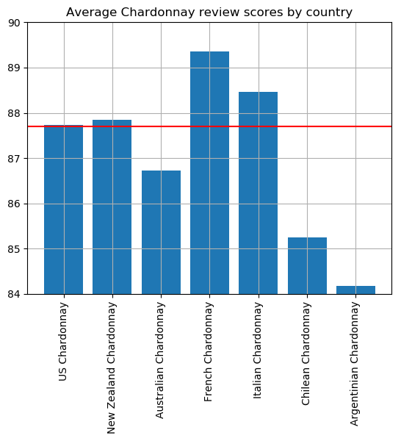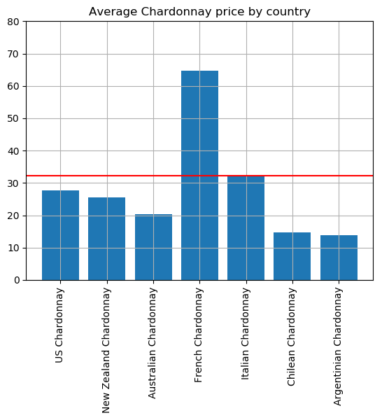
This information can be further illustrated on the scatter plot below, the average price per bottle is on the y-axis and the average score along the x-axis:
Fig 4.
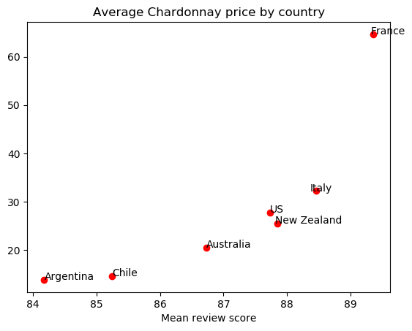

From this data we can make some initial observations:
- The French Chardonnays score the highest average rating points; however, their mean price is approximately double that of the global mean price (its average price is significantly higher than the average of any other country)
- New Zealand Chardonnays are rated slightly higher than those from the US and are available for a slightly lower price
- Italian Chardonnay is on average only one rating point lower than French Chardonnay, but on average less than half of the price

Given that we can see that the average price of a French Chardonnay is significantly higher than the rest of the group, I ran analysis on this dataset to see if there were certain ‘outliers’, i.e. abnormally priced bottles of wine, that were skewing the price averages.
I created the following Scatter plot to observe the spread of the wine prices for the Chardonnay variety in the dataset:
Fig.5
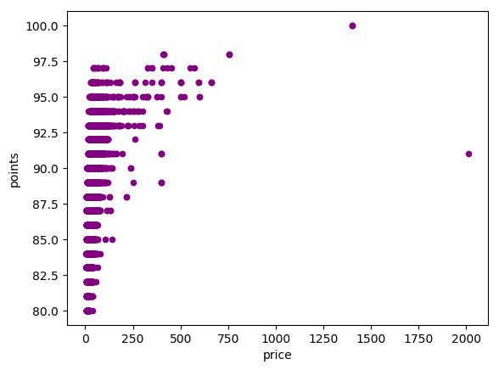
As we can see, there are some outlier wines that are priced significantly higher than the global mean. The scatter-plot highlights points around the $2000 and $1300 regions.
I decided to run another analysis of this same set of data, however this time removing all Chardonnays priced above $750 to potentially give us a more even dataset.
I chose this figure because going by our scatter plot above, most wines are being priced below this point. Here is a scatter plot illustrating this:

Fig 6.
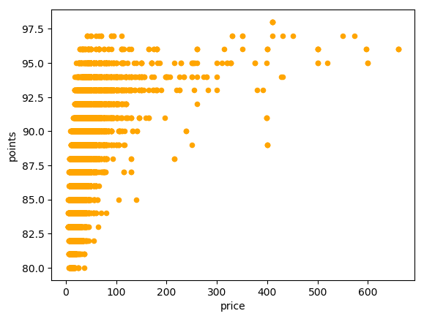
Using this new set of data with a maximum price per bottle set at $750, I ran my original analysis of the means of each country again and observed the following results:
Original data:
Table 2.
Country | Global | US | France | NZ | Australia | Chile | Argentina | Italy
Mean review score | 87.692777 | 87.72991 | 89.362473 | 87.844706 | 86.730135 | 85.244624 | 84.176471 | 88.46
Mean Price (rounded) | 32.247187 | 27.676953 | 64.648614 | 25.491765 | 20.409295 | 14.592742 | 13.812636 | 32.188889
Number of reviews | 13775 | 8101 | 2345 | 425 | 667 | 744 | 459 | 450

New data set (maximum price $750):
Table 3.
Country | Global | US | France | NZ | Australia | Chile | Argentina | Italy
Mean review score | 87.687609 | 87.729506 | 89.337751 | 87.844706 | 86.730135 | 85.244624 | 84.176471 | 88.46
Mean price (rounded) | 31.647371 | 27.431852 | 62.047884 | 25.491765 | 20.409295 | 14.592742 | 13.812636 | 32.188889
Number of reviews | 13768 | 8100 | 2339 | 425 | 667 | 774 | 459 | 450

Difference between initial and subsequent data set:
Table 4.
Country | Global | US | France | NZ | Australia | Chile | Argentina | Italy
Mean review score | -0.005168 | -0.000404 | -0.024722 | 0 | 0 | 0 | 0 | 0
Mean price (rounded) | -0.599816 | -0.245101 | -2.60073 | 0 | 0 | 0 | 0 | 0
Number of reviews | -7 | -1 | -6 | 0 | 0 | 0 | 0 | 0

The following bar charts illustrate the minimal changes between the mean review points and prices, the red lines indicate the mean for the dataset.
Fig 6.

Fig 7.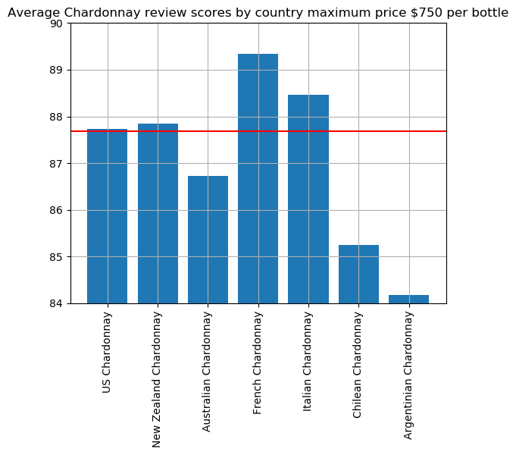

Fig 8.
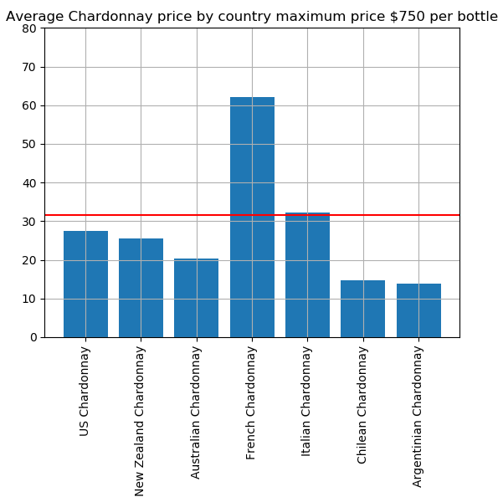

Reducing the maximum price per bottle to $750 removed only the 14 most expensive wines from our dataset, a minimal number in the context of this data. Despite these abnormal outliers being removed, the dataset trends have not changed significantly.

There is still a large disparity in average price in our sample sets between France and the other countries. The expectation that the outlier wines that were abnormally expensive were influencing our data has been shown not to be the case.

Adjusting the criteria

Whilst there is initial visual evidence to suggest that French Chardonnay wines are of higher quality and are significantly more expensive than other wines analysed, I wish to observe another subset to see if we get the same outcome.
To ensure that we are comparing wines on a level playing field, I have decided that I will perform this analysis with wines of a maximum price of $50. In sub setting our data to this grouping, we have kept 12249 reviews, or 88.9% of our Chardonnay data, but the range in price is far smaller and easier to analyse more accurately.
If we observe the scatter plot below, we can see that we have a much more evenly spread range when we adjust to these criteria:

Fig 9. Maximum price $50 per bottle
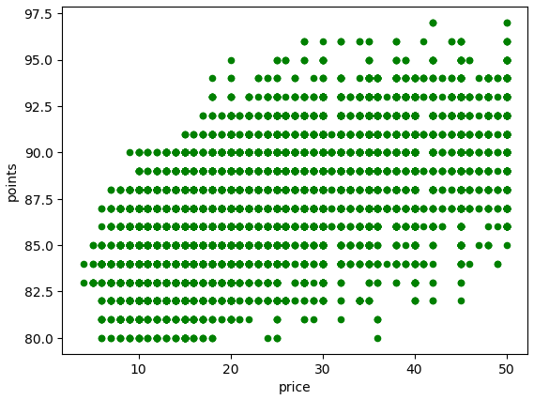

Here is a table for this data at a maximum of $50 per bottle:

Country | Global | US | France | NZ | Australia | Chile | Argentina | Italy
Mean review score | 87.196587 | 87.522819 | 87.578402 | 87.712531 | 86.518809 | 85.223275 | 84.159389 | 88.123426
Mean Price (rounded) | 23.911258 | 25.394877 | 28.088018 | 24.034398 | 17.902821 | 14.239513 | 13.591703 | 26.634761
Number of reviews | 12249 | 7691 | 1352 | 407 | 638 | 739 | 458 | 397

We will examine this in detail in our final analysis.

Final Analysis Results – Dataset one

Statistical Analysis

The hypotheses for this analysis were the following:
Null Hypothesis
H0: µ1 = µ2 = µ3 = µ4 = µ5 = µ6 = µ7 (there is no difference in the mean price for the same variety of wine)
Alternate Hypothesis
H1: µ1 ≠ µ2 ≠ µ3 ≠ µ4 ≠ µ5 ≠ µ6 ≠ µ7 (there is a difference in the mean price for the same variety of wine)
And:
Null Hypothesis
H0: µ1 = µ2 = µ3 = µ4 = µ5 = µ6 = µ7 (there is no difference in the mean rating points for the same variety of wine)
Alternate Hypothesis
H1: µ1 ≠ µ2 ≠ µ3 ≠ µ4 ≠ µ5 ≠ µ6 ≠ µ7 (there is a difference in the mean points rating for the same variety of wine)
Alpha (α) is 0.05, meaning there is a 5% chance of a type I error (rejecting the null hypothesis when we shouldn’t.)

I have conducted Anova Tukey tests to compare in the means of both the prices and the ratings of Chardonnay between the seven countries analysed (all results are in appendix 1).
As per these tests, the majority of the analyses advise that we are to reject the Null hypothesis that there is no difference between the means for both ratings points and price, in favour of the alternate hypothesis that there are differences. The majority of mean rating points scored were not the same and as demonstrated in the charts and graphs included; both the price and points varied significantly between countries.
As stated in the objective, I am going to assess the overall value of the wines in terms of value, to define what we mean by this:
- How many mean rating points a wine from each country achieves for the mean dollar price of a wine in that country.

Full Data set:

Country | Global | US | France | NZ | Australia | Chile | Argentina | Italy
Mean review score | 87.692777 | 87.72991 | 89.362473 | 87.844706 | 86.730135 | 85.244624 | 84.176471 | 88.46
Mean Price (rounded) | 32.247187 | 27.676953 | 64.648614 | 25.491765 | 20.409295 | 14.592742 | 13.812636 | 32.188889
Number of reviews | 13775 | 8101 | 2345 | 425 | 667 | 744 | 459 | 450
Value | 2.7193931 | 3.1697821 | 1.3822798 | 3.4460033 | 4.249541 | 5.8415769 | 6.0941641 | 2.7481533
Dataset with $50 as maximum price

Country | Global | US | France | NZ | Australia | Chile | Argentina | Italy
Mean review score | 87.196587 | 87.522819 | 87.578402 | 87.712531 | 86.518809 | 85.223275 | 84.159389 | 88.123426
Mean Price (rounded) | 23.911258 | 25.394877 | 28.088018 | 24.034398 | 17.902821 | 14.239513 | 13.591703 | 26.634761
Number of reviews | 12249 | 7691 | 1352 | 407 | 638 | 739 | 458 | 397
Value | 3.646675 | 3.4464754 | 3.1179986 | 3.6494582 | 4.8326914 | 5.9849852 | 6.1919679 | 3.3085871

These data illustrate that the lower rated wines are better value for money when we purely rate them in terms of how many ratings points that we get per dollar. The Argentinian and Chilean wines are significantly cheaper than the European and US wines, whilst being slightly lower rated. Based on the criteria outlined, we would conclude that they are better ‘value for money’. For customers who look for value for a bargain, these wines may be a better option to purchase.
To analyse the French wines, we will compare them with their closest contemporaries.
In the larger dataset, the French and Italian Chardonnays are the two highest rated wines, however the French Chardonnays are on average double the price of their Italian counterpart. An argument could be made that at the to get the very best, top rated wines, the consumer will need to pay a high premium, however head-to-head, based on the data that we have examined, the Italian Chardonnay looks to be better value for money, with a slightly lower average rating at a much lower average price.
In the analysis of the wines at a maximum price of $50, we see a much different outcome.

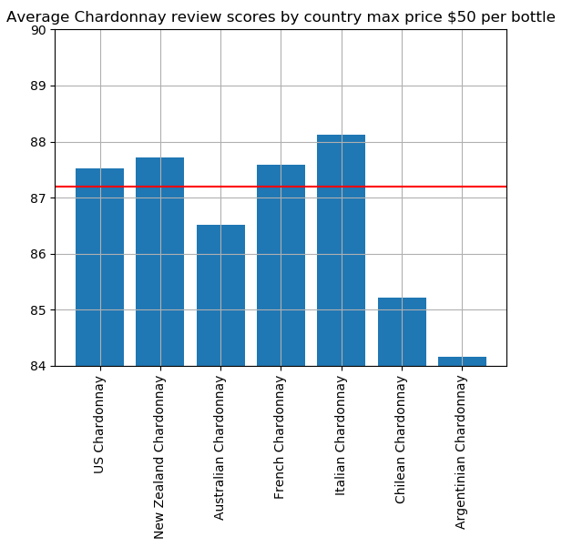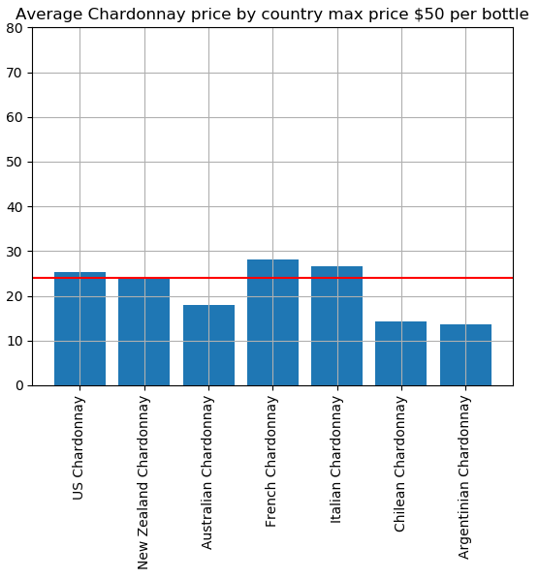

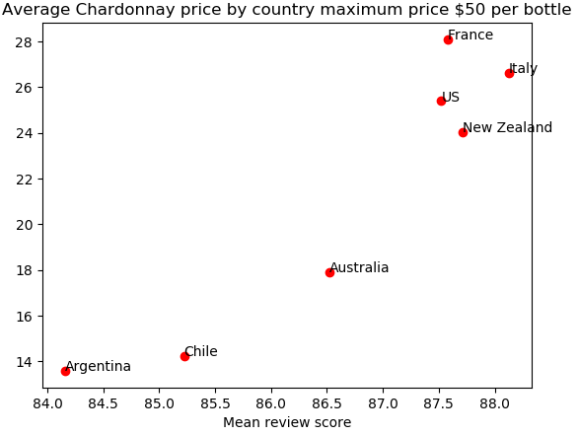

As we can see from our tables of figures and the above bar charts, the Italian Chardonnays now have the highest mean rating points score, followed by New Zealand, with French wines back in third place, only marginally ahead of the US in fourth.
Despite this, we can see that the French wines in this category remain the most expensive.
The results show that an average, and Italian Chardonnay has a higher rating than the French equivalent but is also less expensive.

Conclusion

I will conclude that based on this information, French wines are not the most expensive because of their quality, and that there are other therefore other factors to consider. Economic and environmental factors no doubt have an influence on the cost of wines, but based on the data we have observed, it is possible that the established reputation of French wines as being superior has an influence on their price.

